CSL7110 Assignment 3 Report
Roll Number: M24AID008

1. Objective
The objective of this assignment is to implement and compare different recommendation system techniques using the MovieLens dataset.

2. Dataset Used
The MovieLens latest-small dataset was used, which contains movie metadata and user ratings. It is suitable for experimentation and allows efficient implementation in Google Colab.

3. Assumptions
- Ratings greater than or equal to 3 were considered relevant.
- Top-K recommendations were generated for evaluation.
- Due to dataset sparsity, low precision and recall values are expected.
- Genre information was used as the primary feature for content-based filtering.

4. Methods Implemented
The following recommendation techniques were implemented:
- Content-Based Filtering using TF-IDF and cosine similarity
- User Profile-Based Recommendation
- User-Based Collaborative Filtering
- Matrix Factorization using SVD
- Hybrid Recommendation Model

5. Results and Observations
The models were evaluated using Precision@K and Recall@K.
The observed values were relatively low. This is expected because:
- The dataset is sparse
- Basic models were used without hyperparameter tuning
- Exact matching between recommended and relevant items is difficult
Despite this, all models were successfully implemented and produced valid recommendations.

6. GitHub Repository
The complete implementation can be found at:
https://github.com/Yoursuperherobasu/M24AID008_CSL7110_Assignment3.git

7. Conclusion
This assignment helped in understanding different recommendation techniques and their behavior on real-world data. It also highlighted the challenges of evaluation in sparse datasets and the importance of model improvement for better accuracy.
Sample outputs of recommendations and evaluation metrics are included to demonstrate working implementation.
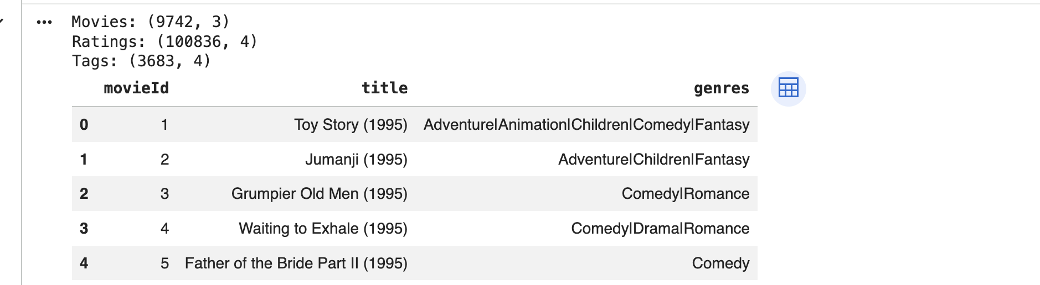
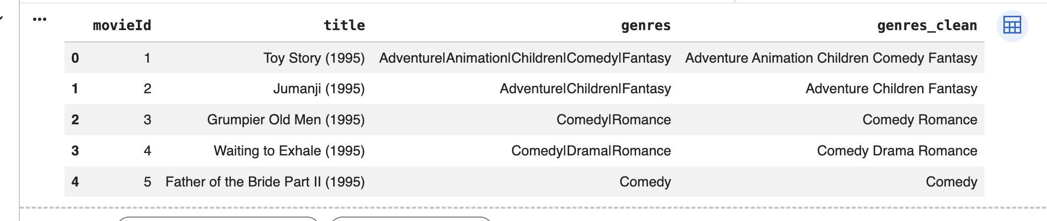
Content Based Filtering:
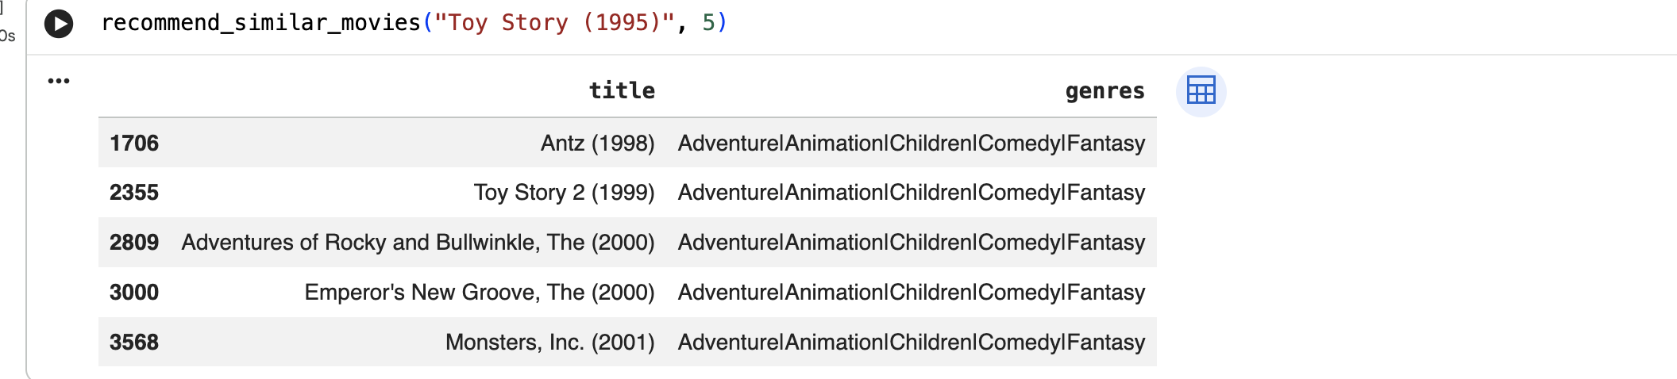
User-profile based Filtering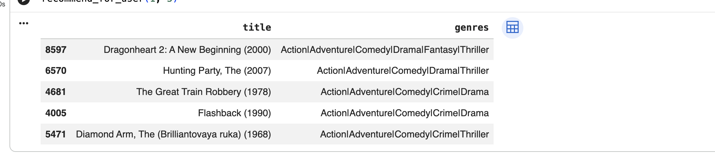Collaborative Filtering:
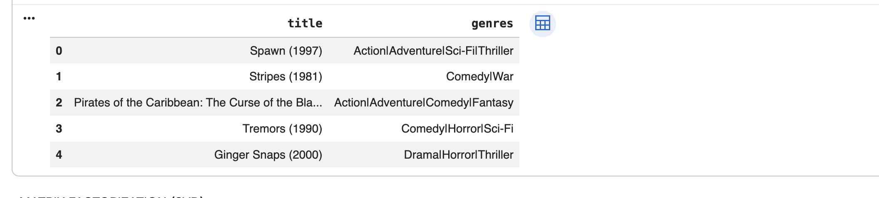
Matrix Factorization:
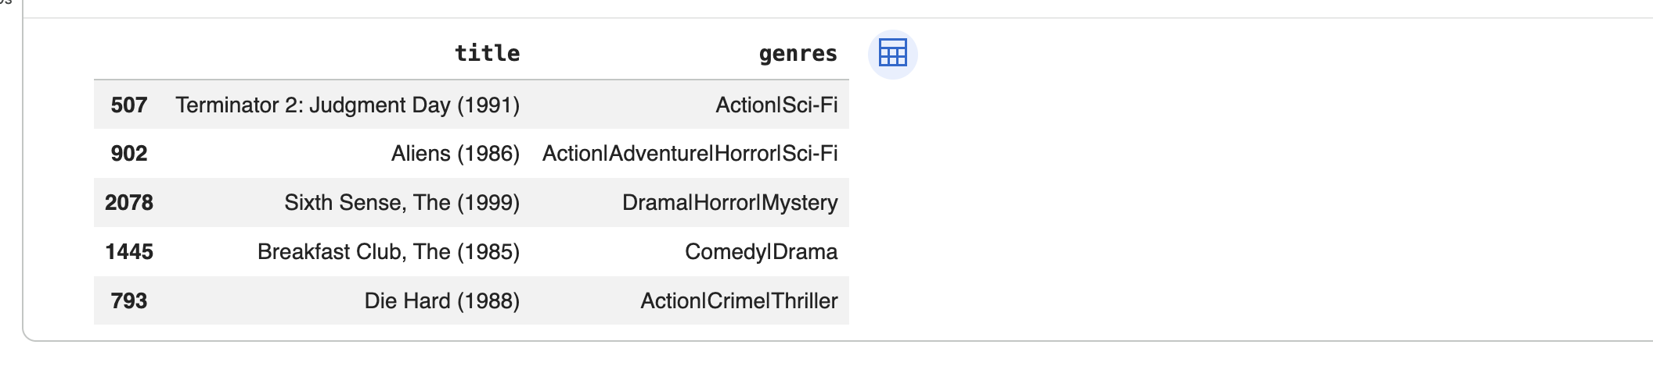Hybrid Model:
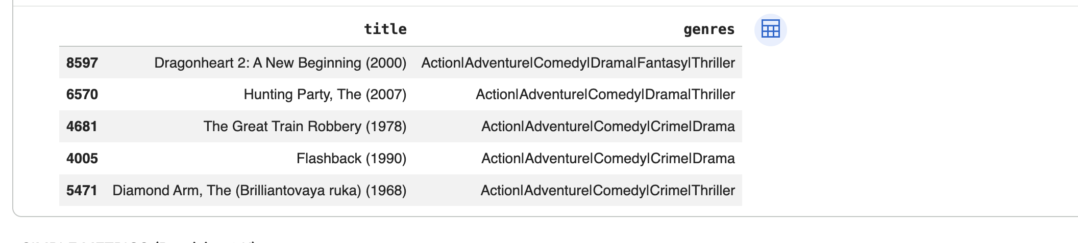
Evaluation Output:
